**A**

**Project Report**

On

“**GSM Based Energy Meter Control”**

Submitted in partial fulfillment for the

Award of degree of

**Bachelor of Technology**

**In Department of “Electrical Engineering”**

 **2012-2013** 

**RAJDHANI INSTITUTE OF RAJASTHAN TECHNICAL UNIVERSITY**

**TECHNOLOGY AND MANAGEMENT KOTA**

**JAIPUR**

**Guided By: Submitted To:**

**Mr. Mukesh sharma Mr. Ashish Dubey**

**Designation:- Lecturer Designation:- H.O.D.**

**(Electrical Engineering) (Electrical engineering)**

**Submitted By:**

**Vikrant Kumar (10ERDEE209) Patel Gaurav R. (10ERDEE207)**

**Ubhadiya Jignesh K. (10ERDEE208) Chawda Manish K. (10ERDEE201)**

**ACKNOWLEDGEMENT**

In this era of global melt down we need a great balance between theoretical and practical knowledge. In this respect the Project presentation is a great boon for the engineering students. We wish to avail this opportunity to acknowledge our profound indebt and extend our sense of gratitude to our **Project** **coordinator Mr. R. K. Shrivastav** and **Project guide Mr.** **Mukesh Sharma** for their valuable guidance, profound advice and encouragement that they had led to the successful completion of this report.

We are exceedingly grateful to our **H.O.D Mr. Ashish Dubey** for his cooperation towards this report completion.

We are exceedingly grateful to our honorable **Principal Mr. Awdhesh Kumar** for the successful completion of this seminar report.

We are thankful to all the faculty members of our department, who have also helped directly or indirectly in our endeavors.

**DECLARATION**

 **2012-2013** 

RAJDHANI INSTITUTE OF RAJASTHAN

TECHNOLOGY AND MANAGEMENT TECHNICAL UNIVERSITY

JAIPUR KOTA

This dissertation entitled “**GSM** **BASED ENERGY METER CONTROL**” is our own work carried out under the guidance of **Mr. Mukesh Sharma** in the Department of Electrical Engineering at Rajdhani Institute of Technology and Management, Jaipur.

This work in the same form or in any other form is not submitted by anyone for award of any Bachelor of Tehnology.

**Projectees:**

Vikrant Kumar (10ERDEE209) Patel Gaurav R. (10ERDEE207)

Ubhadiya Jignesh K. (10ERDEE208) Chawda Manish K. (10ERDEE201)

Mr. Mukesh Sharma

**Project Guide**

Mr. Ashish Dubey Mr. Awdhesh Kumar

**Head of The Department**  **Principal**

(Electrical Engineering) (R.I.T.M, JAIPUR)

Mr. R. K. Srivastava

**Project Coordinator**

**CERTIFICATE**

 **2012-2013** 

RAJDHANI INSTITUTE OF RAJASTHAN

TECHNOLOGY AND MANAGEMENT TECHNICAL UNIVERSITY

JAIPUR KOTA

This is to certify that the work contained in this Project report entitled “**GSM BASED ENERGY** **METER CONTROL**” is in partial fulfillment of the requirement for the award of Bachelor of Technology in Electrical Engineering of Rajasthan Technical University, KOTA is a bonafide work carried out and completed under my guidance and supervision during the academic year 2012-2013.

**Submitted By:**

Vikrant Kumar (10ERDEE209) Patel Gaurav R. (10ERDEE207)

Ubhadiya Jignesh K. (10ERDEE208) Chawda Manish K. (10ERDEE201)

Mr. Mukesh Sharma

**Project Guide**

Mr. Ashish Dubey Mr. Awdhesh Kumar

**Head of The Department**  **Principal**

(Electrical Engineering) (R.I.T.M, JAIPUR)

Mr. R. K. Srivastava

**Project Coordinator**

**ABSTRACT**

The idea for this project is aimed to describe a methodology for remotely monitoring and controlling energy meter readings. It allows you to read energy meters without having to go to every home or business. Distribution and demand for energy in a responsible manner are important requirements for living a long and healthy life. The current energy billing system has several flaws, including excessive use of manpower, human mistakes, and users' incapacity to keep track of their energy use, as well as a rise in the total cost of the operation. A unique approach for extracting information about energy use from a remote location has been developed and tested to address the current disadvantages. This study proposes a GSM-based system for gathering, processing, and notifying consumers of their expenditure. A microcontroller is used in this system, which takes readings at regular intervals and stores them in memory. This capability (remote monitoring) is made possible via a GSM (Global System for Mobile Communications) module that sends information about meter readings to a mobile phone through SMS. The GSM module is not used in the current meter data system. The technique suggested and demonstrated in this research uses the cell broadcasting function of GSM and SMS to wirelessly relay the individual power readings. The Electricity Department benefits from this technology since it allows them to collect meter readings regularly. Conventional meter data techniques are replaced by the proposed application, which enables the energy company to remotely access an existing energy meter. They can also be identifying of meter readings without having to visit each home individually. To offer remote control over different usage, each entity's electronic energy meter is connected to a GSM-based wireless connection module. The billing point is a PC with a GSM receiver that saves the data on the opposite spectrum. On a constant schedule, the billing point gets live measurements from a GSM-enabled power meter, which are then updated in a central database.

# CHAPTER 1: INTRODUCTION

* 1. **OVERVIEW AND BACKGROUND**

Since the commissioning and procedure of the first (GSM) network in 1991, the globe has accepted the criterion for mobile/cell communication/ interaction. Following acceptance, countries all over the world are rapidly expanding GSM infrastructure to provide countrywide coverage. In addition to the initial GSM voice service, the SMS is established as part of the (GSM) phase2 standard in 1992 as a text paging system. Its popularity skyrocketed, making it a common way of notification communication. No-wired network solutions have become increasingly popular for merging automated industries. Due to enhanced technology, wireless technologies and remote-regulator studies have grown in importance and popularity in recent years. One use of wireless communication, such as (GSM) Global System for Mobile Communication, is a remote automated energy meter invoicing scheme that can deliver SMS to the identified user’s smartphone and send the bill information to the utility. The (GSM) Global System for Mobile Communication energy meter scheme eliminates the manual reading method, which requires a human to be present to keep track of the units spent and update the utility invoicing unit’s data to generate the consumer’s bill. However, the automatic GSM energy scheme may extract information from the energy meter and deliver it to the user, including live data.

SMS has expanded its service to include content providers, allowing smartphone customers to access a wider range of services. When the smartphone user is not supposed to react or respond quickly, SMS is a practical mode of communication, particularly for reminders, notifications, and brief comments. Web-based information system purposes such as e-commerce are obtaining increasing public acceptance as ICT and internet technologies improve and expand. More mobile and wireless technologies, such as energy meter reading, invoicing, payment, and distribution regulation, are now possible because of the merging of GSM and ICT networks. Electricity invoicing is currently done by labour and hand reading from home to house. To accomplish total area invoicing, a large number of manpower operators and extended working hours are required.

* 1. **PROBLEM STATEMENT**

The use of a smart metering system has prompted a slew of questions. Furthermore, the authorities assert that the traditional electromechanical scheme functions satisfactorily and does not require replacement. If the country decides to replace the old system with “Smart Meters,” another issue emerges about the recycling or disposal of existing meters. The cost of installing smart meters is in the billions of dollars. It will be difficult to get rid of the meters that are now in use. In addition, in a standard metering system for monitoring power use, the energy supplier firm pays workers to go to each residence and manually record meter readings, which are then utilized for billing, and the bill is subsequently sent or hand-delivered to the consumer. Because the corporation has no control over these meters, this is not just sluggish but also arduous. Humans attempt to alter meter readings by using various unethical techniques resulting in a significant amount of income loss for the government.

* 1. **THE PROJECT’S OBJECTIVE**

The task’s main aim is to build a remote household energy meter monitoring and regulation scheme. Among the other goals are:

* To use GSM/ Global System for Mobile Communication, design a circuit that monitors meter readings regularly and sends messages to the user and the power department.
* To remotely turn on and off the load attached to it.
  1. **PROJECT SCOPE**

The project’s purpose is to create technology that allows a domestic energy meter to be monitored and controlled remotely. This device can use the Global system for mobile to send information about power use to the provider. To gain the requisite theory for the proposed system, existing articles and theses are collected and examined. The components needed for system building are then thoroughly examined and selected. The schematic architecture is then conducted using the component specifications and circuitry schematics. The equipment is combined to make the correct circuitry/schematic when the work is completed. Interfacing 8051 microcontrollers with Sim-com 900 modems to decipher the received message and perform the needed action is the goal of this project. The AT/Advanced Technology command protocol is utilized to communicate between the two. The microcontroller receives an SMS/Short Message Service on the phone, deciphers it, detects/ senses the phone number, and then activates the relays connected to its port to control the appliances. The controller sends an acknowledgement to the user’s smartphone after an active functioning. In addition, the circuit/schematic is tested, and the results of the testing are examined.

**1.5 PROJECT METHODOLOGY**

The goal of the work is to develop technologies that will allow a household energy meter to be remotely monitored and controlled. To begin, a variety of publications, investigations, and journals are combed through for information on this assignment. Following that, the components/items needed for system building are thoroughly investigated and picked depending on the entire scheme layout. The scheme is created using all of the stated components. For the scheme's construction, the required hardware components are constructed and executed. Furthermore, the assembly of the components in a microcontroller is used to simulate a PCB. Testing is done to see how well the system performs. The system is examined, and the desired o/ps are acquired, along with difficulties that must be resolved before they can be employed in real life.

**CHAPTER 2: LITERATURE REVIEW**

**2.1**

<https://www.academia.edu/download/6100656/jcit5-1_paper4.pdf>

https://d1wqtxts1xzle7.cloudfront.net/6100656/jcit5-1_paper4-with-cover-page-v2.pdf?Expires=1643012101&Signature=YW0cmFSyeEB6TRkUKpWYeOg43P~vdtOHcKITCpUjSmY0YsX9Huo7iW-5~bWePB~qy5UsvMK49~WNmUWWv2KY2SEKddFayD0nh4dagypnNui13le0eVV2kzSQODSE9Rs1EMis-eDRUbZqQfdjCKF4HC0HKtfrm5xvPRdmTAWtq9H0tq-1GZfB09bMA4aiI9Em22uCrSxGgJK-bl6GhNxKvdt9I6KIJA1zNZtqe-a9EomAkoyWAoAVYZDd~J7z13kDLvR9I4I6J0ex~Er4vEdzkI8jtFHZ19RVAO4k62vGxj3AgKOu9nCLQJcpjM0oiXQE3AW~ml6K-8JZGbmbSvnEnw__&Key-Pair-Id=APKAJLOHF5GGSLRBV4ZA

The paper explained the design of the GSM modelled Electrical system for Smart Home Applications. The design of GSM-based appliances for home systems was presented in the study. The primary objective was to reduce down power wastes. The GSM modules were used to receive short’s messaging service (SMS) from user’s devices, allowing the controller to execute further operations such as turning on / off household equipment’s like lights and air conditioners. Using programming code, the device was interfaced to the microcontroller and a GSM network adapter. To complete the integration, MPLAB technology was used. The gadget was switched on when the user sends an SMS to the controller at residence. The microcomputer test model managed the electricity home appliances by turning them on or off in line with the user's requirements after receiving the SMS order. To put it another way, it read messages from mobile phones and replies by regulating machinery based on the information received. The prototypes were completed successfully, and it may provide an effective method for harvesting the source of electricity. As a result, the goal of this project would be to create a system that allow homeowners to optimize their power use remotely via SMS.

**2.2**

<https://ieeexplore.ieee.org/abstract/document/4097922>

A brief introduction about the Wireless Communication -Based Networked Meter-Reading Systems was discussed in the paper. This research introduced Bluetooth cellular connectivity and GSM-based linked remotely meter-reading systems. The decentralized design of the distant meter-reading system included measure meters, terminals, a management centre, & a wireless telecommunication system. The smart terminal, which is based on embedded & Bluetooth connectivity, has been used to collect data from meters and sensors, as well as regulate electricity items in the home. The message was sent across the GSM network between the intelligent terminal and the institution type. The hardware and software of this meter-reading system are discussed, as well as the system's structure and operation. Using this technique, the meter-reading duty may be completed at the residence area's management centre. Wireless, workload, large volume of data transfer, high veracity, & low cost are only a few of the system's notable features. The use of an embedded system enhanced wireless information stability. The meter-reading technique from afar, which was found to be advantageous for managing energy sources and ongoing growth, had a wide range of applications.

**2.3**

https://ieeexplore.ieee.org/abstract/document/5360149

The Tenaga Nasional Berhad (TNB), Malaysia possessed the electrical business utility has implemented two methodologies for collection metering data from the consumers. They implemented the traditional procedure for ordinary customers by dispatching the meter-reading regularly to perform the meter reading installed at user end. They employed global system for mobile communication-based (GSM) AMR technologies for big or industrial clients. In this case, a GSM module was linked to the LPC's meter, & data reading may be done automatically without the need for the LPC to visit customers' locations. For OPC clients, the traditional methods had various shortcomings that must be addressed. The phone line or remote techniques such as GSM or the Internet should be used for remote control.  The area framework had often been built using ZigBee, Bluetooth, and Wi-Fi. In between the web and the WLAN, a home portal was necessary for this situation. In this study, Wi-Fi-based machine control was being used, allowing clients to manage the equipment from both within and outside the building. In the previous framework, only one person could operate the home machine; however, in the present system, anybody may control the equipment. It promoted changing the position of the force of the power meter; if the force robbery was discovered, all of the apparatuses were terminated by terminating the heap from the station side.

**2.4**

<https://www.researchgate.net/profile/Maheswari-Chenniappan/publication/41892072_Implementation_of_Energy_Management_Structure_for_Street_Lighting_Systems/links/5638343608ae51ccb3cbeed5/Implementation-of-Energy-Management-Structure-for-Street-Lighting-Systems.pdf>

The objectives of this work would be to create low-cost, energy-efficient street lights using the Global Systems for Mobile Communication [GSM] & General Packet Radio Service [GPRS]. GSM & GPRS were employed on the operator side to establish the connection between streetlights or Central Monitoring Station [CMS]. The entire set-up allowed remote operators to switch off the light when they weren’t in use, manage energy provided to streetlights, and provide daily gleaming hours records. The major advantages of remote energy tracking and controlled methodology were energy-saving and lower service charges. Energy savings can be achieved by ON/OFF control, as well as minimal maintenance due to rapid reporting of flaws and the measurement of glowing hours. The focus of this work was on the monitoring and controlling of lighting. Power outages can also be sent to remote CMS operators using GSM / GPRS connection. The readings from the power meter installed in the artificial lighting are sent to the remote CMS through a short message [SMS]. The ability to identify street light failures within hours can assist to cut down on median lamp maintenance by a significant amount. Data may be gathered on pollution ratios, air quality, humidity, temperature, transport, and noise complaints.

**2.5**

<https://ieeexplore.ieee.org/abstract/document/5712393>

The paper introduced a smart energy meter for the conservation of energy. The assessment of voltage quality aids in lowering the expense of the energy and extending the duration of the components. Smart metering was a sophisticated end-to-end approach that enabled the transmission of high-quality electricity and eliminates errors. It is an energy strategy aimed to provide consumers with a user-friendly interface for dealing with a utility bill (particularly electricity bills). It offered consumers a Digital Meter that displayed real-time use in a highly friendly & thorough style at all times where they can monitor and determine their energy consumption & costs using different graphs, tabulated and manipulated data. Through the use of automated Power Factor Scheduled maintenance, it not only gave comfort to its customers but also provides relief by minimizing real power loss and providing anti-power theft features. More mobile and wireless activities, such as energy meter reading, billing, payment, and distribution control, are now possible because of the convergence of GSM and ICT networks. Electricity billing is currently done by labour and hand reading from home to house. A significant number of working operations and heavy workloads were necessary to complete the entire area billing. It also created power distribution control, which allowed the Distributor to prohibit consumers from breaching their power usage restrictions for a certain duration of time.

**2.6**

<https://ieeexplore.ieee.org/abstract/document/4389381>

Many architects and firms have been working on automatic meter reading (AMR) in the latest days, and many mediums have been employed for this purpose, including radio, telecommunication networks, and electricity lines. Nowadays, the Gsm system was gaining popularity as the primary medium for machine-to-machine applications, its widespread coverage in most countries and its robust, ever-growing industry, and AMR was no exception. Using GSM as an AMR medium was currently not cost-effective for home meters, however, it is cost-effective for commercial and industrial (C&I) meters. If the power exceeded the predetermined limit, the control system will regulate the power using various ways for different types of loads, such as resistive and inductive huge amounts, to decrease needless appliance energy consumption and conserve energy. This article highlights key aspects of a project recently completed that leverages GSM/SMS as an AMR medium. The method was created with C&I meters in mind. SMS had expanded its service to include content creators to give a wider range of services to mobile phone customers. SMS was a useful mode of communication for reminders, notifications, and brief messages when the mobile phone user is not expected to answer or reply right away. With the growth and progress of ICT and online technology, online information system applications such as e-commerce were obtaining increasing public acceptability.

**CHAPTER 3: COMPONENTS USED**

**3.1 GSM**

GSM Modem is implemented with an easy-to-implement RS232, TTL Serial, and module reset pinout. Use it to send SMS, make and receive calls, and other GSM activities using AT instructions from embedded devices and computers over a serial interface. For all GSM activities, it employs the widely used SIM300/SIM900A module. It has a standard RS232 interface that may be used to connect the modem to microcontrollers & PCs with ease. The GSM energy meter system can eliminate the physical reading method, which requires a human to be present to keep track of the units spent and update the utility billing unit's databases to generate the customer's bill. However, the automated GSM energy system may extract information from the energy meter and deliver it to the user, including live data. A serial TTL interface is also available on the transceiver. Sending AT instructions to serial ports via serial terminals software may be used to do any modem activities (such as transmission and reception, making calls, and so on).

**3.2 Energy Meter**

An electricity meter, also termed a Watt-hour Meter, is a device that monitors how much electricity a consumer consumes. Kilowatt-hours are used to calibrate the meter. The quantity of electric energy required to provide 1,000 watts of electricity with one hour is one kilowatt-hour. Electric meters are used by electric power companies to track how much electricity each of their customers consumes. An electric meter is installed by the electric company near the point where its power lines enter a building. It scans the meter regularly and bills the consumer for the power utilized. Multimeters indicate the amount of power consumed on an LCD or LED display, and some can even transfer data to a distant place. In addition to monitoring electricity, monitoring systems may store many parameters of load and supply, such as immediate & maximum rate of consumption needs, voltages, operating voltage, and real and reactive used.

**3.3 Relay**

A relay is indeed a switch that is activated or deactivated electrically. The device is made up of a set of inverting input for an or several broadband applications, as well as a set of working contact interconnections. Any level of connectedness in any contact form, including creating contracts, breaking contact details, and mixtures of the pair, is possible with the switch. When a separate low-power signal is needed to operate a circuit, or when several circuitry must be dominated by a single transmission, the relay can be used. The essential concept of operation for all relays is the same. In this example, we'll utilize a standard 4-pin connector. A control circuit (shown in GREEN) and a load circuit (shown in RED) are both included in relays. A tiny control coil is used in the control circuit, whereas a switch is used in the load circuit. The spool of wire. The switch's action is controlled. Relays were first used in long-distance sharing of information as signal transponders, renewing the information coming in from one circuit by disseminating it on another. Relays were frequently used in telephone systems and early processors to perform logical functions.

**3.4 Diodes**

Diodes are essentially a single-headed current value that allowed to flow of the electrical supply in one way from positive terminal to negative end. The procedure of the rectification or conversion of AC to DC clipped off the negative component for the AC waveform design. When the diode is designed either in the forward biased and conducting current, then the diodes are arranged in anode or cathode terminals placed inside the supply circuit configuration. The arrow is placed in the symbol point towards the cathode terminal signifying the flow of current in both directions. Most diodes resemble resistors and feature painted the line on one end to indicate its direction.

**3.5 Microcontroller**

The microcontroller is a general-purpose device with an 8-bit operation for the improved efficiency and usage of energy which was responsible to execute to perform 131 operations. The functions are operated in a single clock cycles for the innovation of the RISC architecture. The Harvard architecture is also included in this configuration. It is distinguished by six sleep modes, an integrated ADC (analog to digital converter), an inbuilt oscillator, and serial data transmission, and it executes instructions in a cycle. These microcontrollers were incredibly fast and consumed very little power while operating in several power-saving modes. AVR arduino boards are available in a variety of configurations to perform a variety of functions, including 8-bit, 16-bit, and 32-bit. The microcontroller was programmed to make a decision based on the inputs. The LCD was then attached to the control board to display the user instructions.

# CHAPTER 4: DESIGN

## 4.1 COMPONENT SELECTION

The needed components are selected using references from various publications and methodologies. After identifying the components and determining which ones are required to create the scheme, the components are chosen based on their intended use. The AT89S52 microcontroller is chosen because it is low-power and offers good performance while being simple to program. Next, choose 7805 voltage/potential regulators for voltage/potential control from the power supply's o/p. After that, pick MC78XX/LM78XX/MC78XXA regulators with o/p voltages/potentials that are stable. The Diode IN4007 is chosen at this point. A voltage/potential controller/regulator with an (I)current limiter, thermally down function, and only runs in a harmless working region is utilized for complete safety of the devices provided. Furthermore, a sugar cube Relay is used to control/regulate the loads. The SIM900 Modem with GPRS is then selected for SMS communication/ message. For statistics communication with the AT89S52/ microcontroller, an energy meter with a port is used. Furthermore, a 16x2 LCD is used to show the data, as well as components such as capacitors (C), resistors (R), and diodes (D) to complete the circuit/schematic. A bridge rectifier/converter and filter circuit convert the Alternating Current power source and feed it to the voltage/potential regulator. Furthermore, Keil software is used to program the microcontroller.

**4.2 BLOCK DIAGRAM**

Selecting the essential components/items, employing the gadgets, and creating the scheme with schematic figures while keeping the work's goal in mind. The AT89S52 microcontroller is connected to the SIM900 modem, which deciphers the message and sends it to the phone through SMS/Short Message Service. For interaction between the microcontroller/AT89S52 and the GSM modem, the (AT)Advanced Technology command protocol is used. Additionally, the energy meter is interfaced well with the AT89S52 by coupling the energy meter's signal port to the AT89S52 /microcontroller, where a certain pulse value represents one unit. A voltage regulator provides a 5Volt supply to the microprocessor through a power supply. Furthermore, a system is built in which the microcontroller receives data from the energy meter and sends it to the smartphone through the GSM’s modem, as well as to the LCD for display. A sugar cube Relay is also used to manage and regulate the loads/demands.  The technology in this project is intended to deliver automated meter statistics directly to the government, as well as regulation over it to close the electricity if the consumers do not pay the electricity fee.

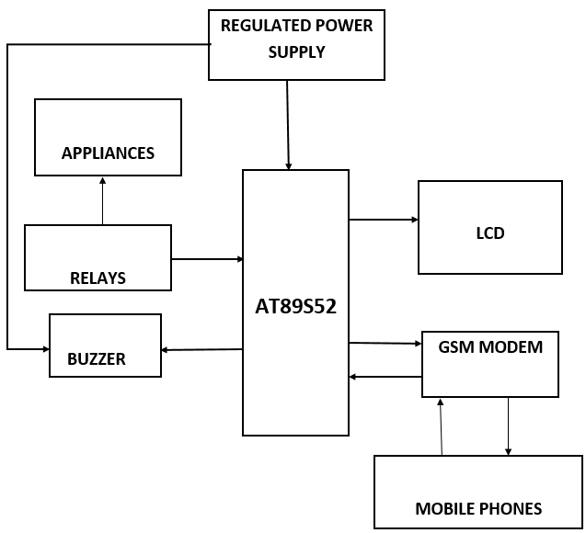

**Figure: Block diagram**

**4.3 CIRCUIT DESIGNING**

The hardware components/items are used to put together the intended system. The PCB board is used to connect the components and construct a full hardware scheme by inserting them in the holes. Furthermore, the soldering is done using a soldering iron after cleaning the (PCB)Printed Circuit Board with isopropyl alcohol. Connect the rectified/converted and regulated 5V power/energy supply to the microcontroller VCC first to complete the circuit. A hardware/physical switch/button is also attached to turn the scheme on and off. The LCD is linked through port P2.7 to port P2.0, and the RW ports are used to adjust the LCD as needed. The Vee is connected to the surface through an (R) resistor to provide the (-ve) negative potential. The Global System for Mobile Communication regulation is provided via the microcontroller's pins Transmit Data and RXD/Receive Data, while the energy meter is attached to pin INT0. Following the completion of the assembling procedure, the circuit is tested. The system is set up such that the (GSM) Global System for Mobile Communication sends an (SMS) Short Message Service when a particular number of units have been consumed, as well as implementing a smartphone instruction for getting statistics as required.

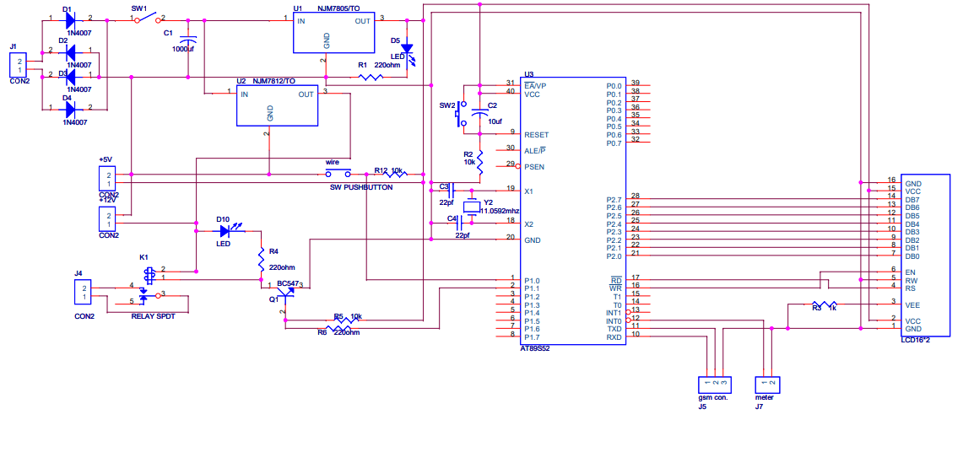

**Figure: A diagram of the system's circuitry is shown**

# CHAPTER 5: ASSEMBLY AND TESTING

**5.1 ASSEMBLY**

To build a PCB layout for showing and hiding devices, a circuit schematic is printed and etched. All the needed items such as AT89S52 microcontroller, energy meter, Global System for Mobile Communication/GSM’s modem, LCDs, relay, LED display, wires, and so on are taken and placed on the wooden board or Plywood. The circuit can be readily built by mounting and soldering the components in the holes supplied by the P.C.B. since it has been planned and fabricated. Following the soldering of the components to the PCB, continuity tests are performed to check that the components are properly connected. Following that, drilling is done for the corresponding components to solder to the PCB, and short circuits in the connection are examined. The device's loose connection is held in place with a glued. A mounting base is included in the packing materials, which is encased in a casing that grips the Printed Circuit Board(PCB) and Global System for Mobile Communication modem/Modulator-Demodulator. The base material's description may be found below. Plywood serves as the foundation for the construction's casing and other exterior connections. This is chosen since it is both functional and neat. The case's side is additionally pierced to provide access to the GSM modem's antenna and external connections.

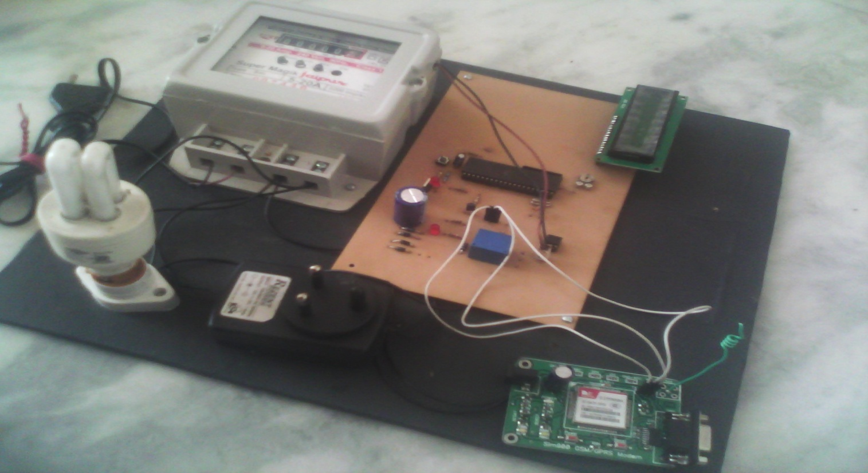

**Figure: Hardware of the Design System**

**5.2 TESTING**

Testing of the entire system is done to see if the intended system is capable of working correctly or not. Following the attachment of the components to the Printed Circuit board, integrity tests are done. The configuration looks to be in fine working order. After that, the panel is packaged by placing it in the case. The SMS(Short Message Service) instruction to "Connect/Link" the meter is given after attaching the metering device to a power supplier. The metering device answers with an energy use estimate. Additional commands are transmitted to 'load/demand' the meter, "disconnect/detach" the meter, and obtain the meter device's state as "Report/Monitor." During testing, the problem occurs when the LCD tries to correctly show the information. The display is quite dull, and it even flickered at times. The pins on the LCD that are linked to the microcontroller are examined and re-interfaced. However, the interface does not provide a solution. The program in the Keil software has been double-checked, but it is still functioning. The microcontroller problem is investigated, but it is likewise found to be in working order. The task supervisor's conversation highlights the source of the problem. The issue is with the Vee that isn't equipped with a resistor. As the LCD's Vee/Voltage at the common-emitter pin is used to regulate the contrast, this reduces the contrast. As a result, adding one Kiloohm resistor(R) in front of the Vee/Voltage at the common-emitter pin regulated the LCD's intensity and rendered it viewable, eliminating the display's flickering.

# CHAPTER 6: RESULT AND DISCUSSION

## 6.1 RESULT

The required results/outcomes are produced and observed after the assembling and testing phase. After a few hours of the load attached to it, the energy meter displays the units. The information is then shown on the LCD, which includes the unit's Wattage and pricing. The SMS is sent at any time, and the smartphone is used to issue a command. The entire wattage and unit consumed, as well as the overall cost of consumption, are included in the SMS. For the overall cost estimation, the components are also mentioned. For the hardware to be built, a total of Rs. 4700 is required. A GSM modem, which costs Rs. 3000, is the most costly piece of gear. The development and installation of the (AMR)Automatic Energy Metering System successfully demonstrate the use of GSM technology to create labour-saving and free from mistake power invoicing systems with these results.

|  |  |  |
| --- | --- | --- |
| Components/Items | Quantity/Number | Amount in(RS.) |
| (GSM) Global System for Mobile Communication Modem | 1 | 3000/- |
| Energy Meter | 1 | 500/- |
| IC (AT89S52) | 1 | 100/- |
| LED Display | 1 | 100/- |
| Relay | 1 | 50/- |
| P.C.B. | 1 | 200/- |
| S.M.P.S. | 1 | 100/- |
| Wires | 1 | 100/- |
| Rectifier Circuit | 1 | 50/- |
| Miscellaneous |  | 500/- |

**Table: Component Costing**

**6.2 DISCUSSION**

In this task, 8051 microcontrollers are interfaced with Sim-com 900 modems to interpret the incoming message and perform the needed action. AT command is the protocol utilized for communication/ interaction between the two. The microcontroller reads the SMS from the phone, decodes it, detects the phone number, and then turns on the relays connected to its port to control the appliances. Following a successful operation, the controller sends an acknowledgement to the user's mobile phone through SMS. During testing, the issue arises when the LCD attempts to display the information accurately. The display is extremely poor, and it occasionally flickers. The LCD pins that are connected to the microcontroller are checked and re-interfaced. The interface, however, does not give a solution. The Keil software program has been double-checked, but it is still operational. The microcontroller problem is explored, but it is also discovered to be functional. The task supervisor's talk focuses attention on the root of the problem. The problem is with the Vee that lacks a resistor. Because the LCD's Vee pin is used to control the contrast, this lowers the contrast. As a consequence, placing a 1K ohm resistor in front of the (Vee) Voltage at the common-emitter pin controlled the LCD's contrast and made it readable, thereby removing the display's flickering.

# CHAPTER 7: CONCLUSION

We realized after working on the project **"GSM BASED ENERGY METER CONTROL"** that the gsm modem has a wide variety of uses. Electrical utilities (EUs) have been using automated Meter Reading (AMR) technology in the distribution system to charge their customers quickly and economically. This system's benefits include detailed analysis, openness, and ease of maintenance and extension. This (AMRS) is now being used in real work and has been proven to be accurate. An AT89S52/microprocessor-centered AMRS is deployed, permitting transfer of data between distant meter reading equipment and the service regulate centre to be inexpensive, reliable, and intervention-free. The microcontroller reads the SMS from the phone, decodes it, detects the phone number, and then turns on the relays connected to its port to control the appliances. Human intervention is not required in meter reading and management operations. This meter reading method is particularly adaptable for service sectors to acquire, serve, and preserve because it is based on existing telephone networks. The entire wattage and unit consumed, as well as the overall cost of consumption, are included in the SMS.

**Advantages:**

* Tracks remote energy meters in an easy-to-use manner.
* It makes it easier to manage the meter.
* It's possible to handle it from anywhere on the planet.
* Tracking energy readings using non-volatile storage.
* Detachment is automatic.
* The supply may be turned on and off automatically.

**Limitations:**

* Because much of the equipment in this system is electronic, it must be maintained and checked regularly.
* It is also vital to locate the GSM modem in an area with adequate network coverage.

# CHAPTER 8: FURTHER WORKS

Further research work in the area of tampering in meters can be done as this appears to be a severe setback, however, no system is completely safe. Furthermore, the following methods can be used to improve dependability and efficiency:

* Tamper-proof seals and labelling, tamper-resistant fasteners and locks, and a non-magnetic enclosure are all recommended.
* Also being explored is the integration of customer load management with the metering system.
* Other control techniques, such as wireless connection via the internet, as well as lower development costs and the inclusion of a graphical user interface, are being implemented (GUI).